Course Syllabus: MA7007 Methods of Applied Math
Semester 2023-2024 fall

Instructor: ZHANG, Zhen （张振）
Office: School of Science M5014
Phone: 88018753
Email: zhangz@sustech.edu.cn

Office hour: Every Tuesday afternoon, 15:00-16:00; or send email to make an appointment for other time.

Lecture: 3 credits, 3 hours per week, location: 3rd Teaching Building 308 (Wednesday 10:20-12:10, Bi-weekly Monday 16:20-18:10).

Prerequisite: Ordinary differential equations A (or B), Partial differential equations, Complex analysis.

Requirements: Approximately 7 homework assignments (Once per two weeks). Please hand in your homework to me or TA in class. The midterm and final exam will be close-book written exams.

Your grade will be based on assignments (35%), attendance (5%), closed-book midterm exam (20%) and final exam (40%).

Main Contents: This course is intended for graduate students and high-level undergraduate students who are interested in modeling and computational mathematics in science and engineering. It provides a concise and self-contained introduction to asymptotic methods and perturbation theory for obtaining approximate analytical solutions to differential equations. Major topics include dimensional analysis, perturbation methods for algebraic equations, local analysis of solutions to differential equations, asymptotic expansion of integrals, global analysis and perturbation methods, matched asymptotic analysis (boundary layer), WKB theory, multiple-scale analysis, homogenization method, bifurcation and stability, and some further topics including variational analysis and Onsager’s principle.

References:
1*. (Textbook) C. M. Bender and S. A. Orszag, Advanced mathematical methods for scientists and engineers, Springer, 1999.
2*. M. H. Holmes, Introduction to perturbation methods, Springer-Verlag, 1995.
3*. A. W. Bush, Perturbation methods for engineers and scientists, Boca Raton, 1992.
4*. E. J. Hinch, Perburbation methods, Cambridge University Press, 1991.
5^. A. Bensoussan, J.-L. Lions, G. Papanicolaou, Asymptotic analysis for periodic structures, North-Holland, Oxford, 1978.
6^. U. Hornung, Homogenization and porous media, Springer, 1997.
7^. G. A. Pavliotis, A. M. Stuart, Multiscale methods: averaging and homogenization, Springer, 2008.
8#. Bruce van Brunt, The Calculus of Variations, Springer-Verlag, 2004.
9#. 张恭庆，变分学讲义，高等教育出版社，2011.
10#. M. Giaquinta and S. Hildebrandt, Calculus of Variations, Vol. I and II, Springer, 1996.
11#. Daniel Liberzon, Calculus of Variations and Optimal Control Theory, Princeton University Press, 2012.
The books with * are standard textbook about perturbation methods; books with ^ concerns mathematical homogenization methods; books with # discuss calculus of variations.

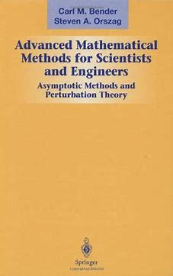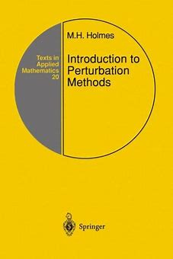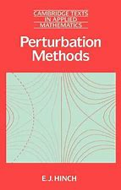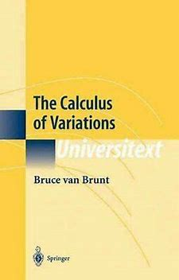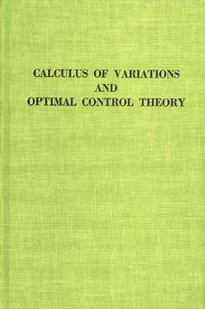

Course Schedule

- Introduction and dimension analysis
- Nondimensionalization
- Fundamental system of units
- Self-similar solutions

- Perturbation methods for algebraic equations:
- Regular perturbation
- Singular perturbation
- Non-integer powers
- Logarithms
- Eigenvalue problems

- Local analysis for the solutions to ODEs
- Series solutions to ODEs
- Types of points of homogeneous linear ODEs
- Frobenius methods
- Method of dominant balance

- Asymptotic expansions
- Asymptotic sequences
- Asymptotic power series
- Properties of asymptotic series
- Asymptotic series vs. convergent series
- Other asymptotic expansions

- Asymptotic expansion of integrals
- Direct expansion of integrands
- Integration by parts
- Laplace’s method
- Method of stationary phase
- Method of steepest descent

- Introduction to global analysis and perturbation methods
- Example of perturbation method
- Asymptotic expansion in \epsilon
- An example with direct expansion
- Regular vs. singular perturbation problems

- Boundary layer theory
- Boundary layer problems
- Boundary layer theory
- Location of boundary layer
- Higher order boundary layer theory
- Boundary layer thickness and distinguished limit
- Boundary layer problem including logarithm term
- Multiple boundary layers
- Internal boundary layer
- Boundary layer in PDE problem

- WKB theory
- Introduction
- WKB theory
- More remarks on the asymptotic expansions
- Problems with turning points
- Eigenvalue problems (Storm-Liville problem)
- Application to wave equations
- Inhomogeneous linear equations

- Multiple scale analysis
- Secular terms
- Method of strained coordinates
- Multiple scale analysis
- Slowly varying coefficients
- Method of averaging

- Homogenization method
- Background
- 1D problem
- Multi-dimensional problems
- Porous medium flow – Darcy’s law

- Bifurcation and stability
- Linearized stability of steady states
- Limit cycle and Hopf bifurcation
- System of ODEs

- Basic calculus of variation
- Introductory example – geodesic on a sphere
- First variation: Euler-Lagrange equation
- Isoperimetric problems – Catenary problem
- Holonomic constraints: Lagrange multipliers
- Free boundary problems – natural boundary condition
- Hamilton-Jacobi system*
- Noether’s theorem*
- Second variation*
- Onsager’s principle

- From calculus of variation to optimal control theory: an introduction*
- Basic formulation
- Pontryagin’s maximum principle
- Dynamical programming and Hamilton-Jacobi-Bellman equation
- Linear quadratic regulator

